ПРИЛОЖЕНИЕ к НОД

«Путешествие по сотровам»

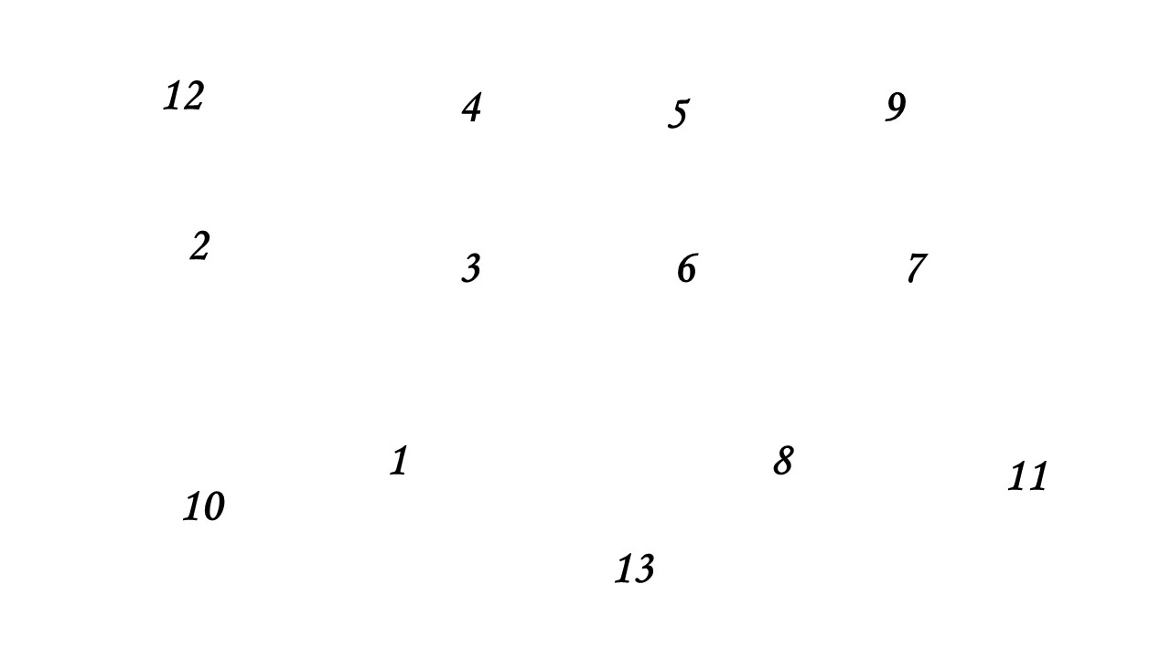1. Числовой ряд

2. «Листья и плоды»

|  |  |
| --- | --- |
| https://www.svoimi-rukamy.com/images/wp-content/uploads/2019/09/list-shablon_23.jpg | https://flomaster.club/uploads/posts/2020-06/1593114737_15-p-raskraski-zhelud-80.png |
| https://i.pinimg.com/originals/44/62/cd/4462cd45a335407d3e89cceb27cdd4a4.jpg | C:\Users\izoto\Downloads\000006.jpg |
| https://www.svoimi-rukamy.com/images/sites/default/files/styles/780w/public/1kak_narisovat_klenovyy_list_27.jpg | https://testua.ru/images/test-kryl-vyr.jpg |
| https://mishka-knizhka.ru/wp-content/uploads/2019/02/raskraska_listja46.jpg | C:\Users\izoto\Downloads\prostaya-ryabina.jpg |
| https://xn--80aeegleao0afjmb9p.xn--p1ai/sites/default/files/listvennica_sibirskaya_-_vetochka_s_pyatyu_korotkimi_pobegami_iz_flory_sssr.jpg |  |
| https://i.pinimg.com/originals/bb/15/82/bb1582bb42891b98c7e33bd4ae8627ea.png | https://thumbs.dreamstime.com/b/%D0%BA%D0%BD%D0%B8%D0%B6%D0%BA%D0%B0-%D1%80%D0%B0%D1%81%D0%BA%D1%80%D0%B0%D1%81%D0%BA%D0%B0-%D0%BA%D0%B0%D1%88%D1%82%D0%B0%D0%BD-111201821.jpg |
|  | https://www.gutenberg.org/files/26158/26158-h/images/28.jpg |
| https://i.pinimg.com/originals/42/c8/fb/42c8fb1f50e4076a6ed01a83e99e0748.jpg | https://www.gutenberg.org/files/34740/34740-h/images/i_320.jpg |

3. «Состав числа»

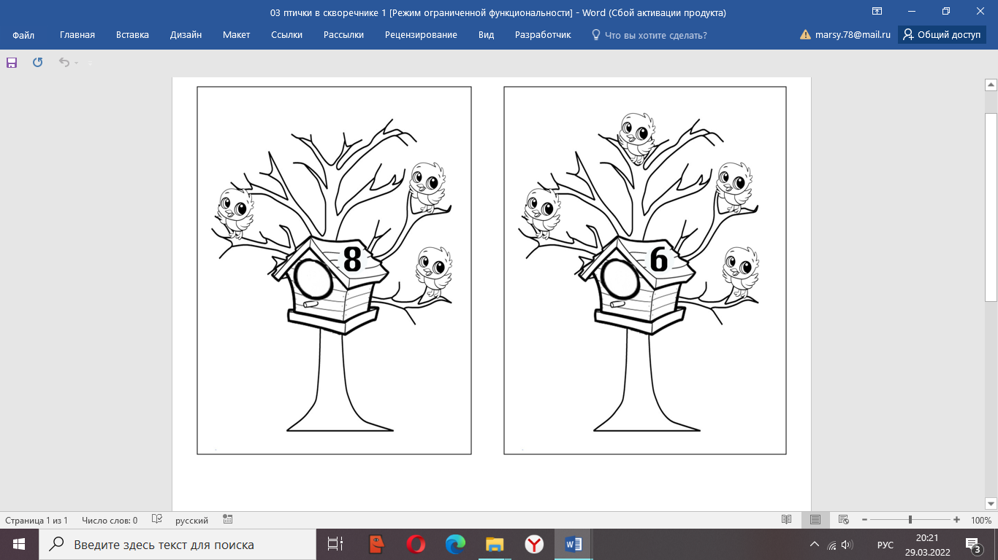

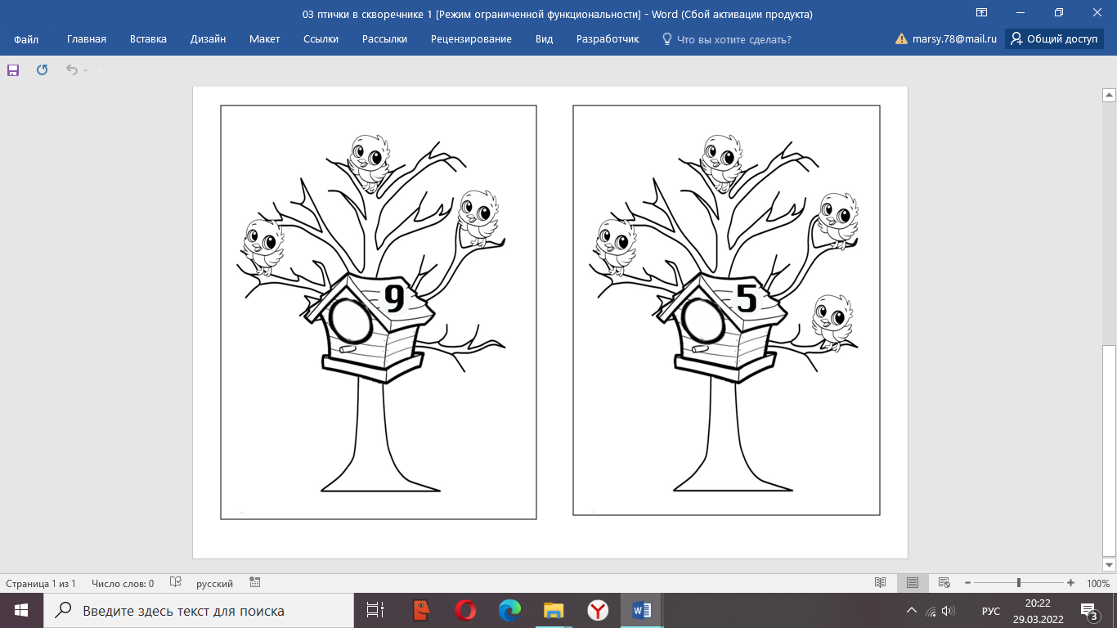

4. «Дорисуй половинку»

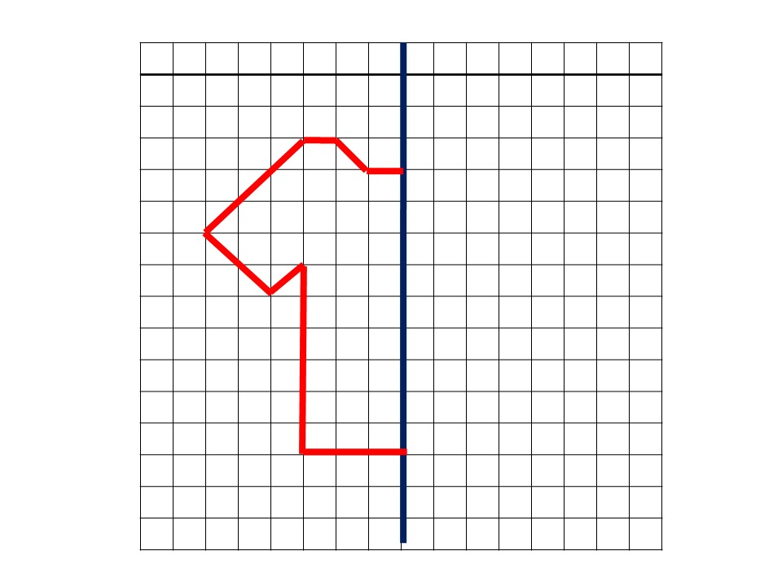

Медали

